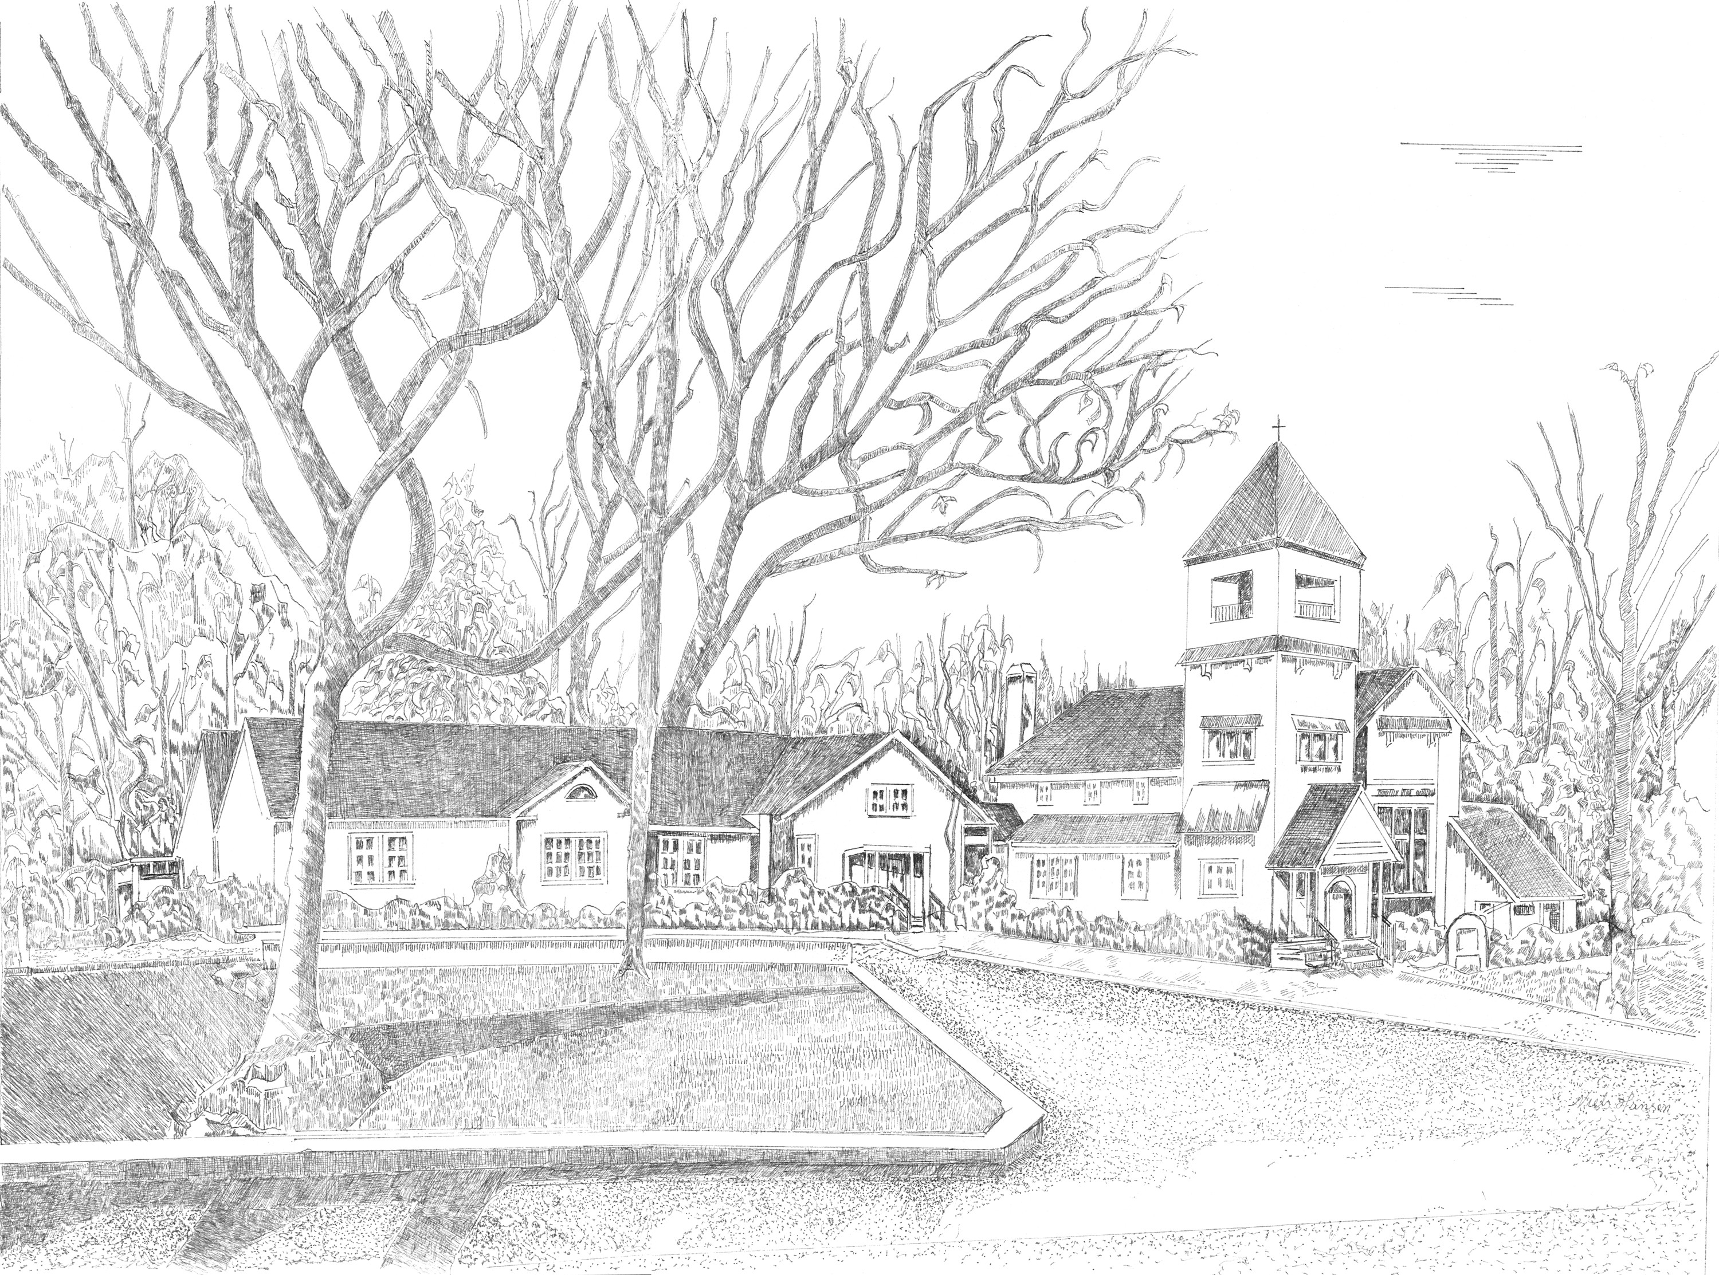
Westhampton Presbyterian Church
on Quiogue

Founded 1742

90 Meeting House Road
Westhampton Beach, New York, 11978
(631) 288-2576
Fax (631) 288-6011

SUMMER WORSHIP
9 AM QUOGUE CHAPEL
10:15 AM SANCTUARY

Pastor
Rev. Michael Hafele
Director of Music
Kamilla Ozman
Youth Ministry Coordinator &
Sunday School Superintendent
Kathy Tureski
Sunday Sexton
Brian Babcock
Administrative Assistant
Erika Lukert

Faithfully Friendly For All – Always
Welcome U Include U Involve

12th Sunday after Pentecost August 31, 2025
*Please stand as able Please silence all cell phones
PREPARATION
Silent Meditation Psalm 112:1-2
Praise the LORD! Happy are those who fear the LORD, who greatly delight in his commandments. Their descendants will be mighty in the land; the generation of the upright will be blessed.
Prelude “Air” Samuel Wesley
Greetings and Announcements
Ringing of the Bell
*Call to Worship
Happy are those who fear the Lord,
who delight in God’s commandments.
They rise in the darkness as a light for the upright.
Those who love God are gracious, merciful, and righteous.
They are generous, sharing freely what they have received.
It is well with those who live in justice.
Their hearts are steady; they will not be afraid.
Let us praise the Lord!
*Hymn 14 “For the Beaty of the Earth”
CONFESSION AND PARDON
*Unison Prayer of Confession
Merciful God, in Jesus you show us a way that is humble and that seeks the good of others. We confess that we go our own way; we elevate ourselves and ignore the needs of others. Free us from the temptation to pursue our own pleasure only. Help us to live in harmony with all your people, sharing one world and eating around one table, for the sake of Jesus Christ our Savior. Amen.

*Assurance of Pardon
Hear the Good News! The mercy of the Lord is from everlasting to everlasting. Be at peace, beloved for it is in Christ that we all are forgiven. Amen!
*Response of Praise No. 581 “Gloria Patri”
Exchange of Christ’s Peace
L: The peace of Christ be with you. P: And also with you.
HEARING THE WORD OF GOD
Children’s Sermon (10:15am service only)
Congregation sings “Jesus Loves me”
Anthem “The Prayer” Sager/Foster
Soloists: Various Choir Members
Scripture Readings Jeremiah 2:4-13, Luke 14:1, 7-14
L: This is the Word of the Lord. P: Thanks be to God!
Sermon “You’re Cordially Invited” Rev. Michael Hafele
*Hymn 282 “Come Down, O Love Divine”
Pastoral Prayer and the Lord’s Prayer
DEDICATION AND RESPONSE
Thanking God through the Offering
*Doxology 606 “Praise God from Whom All Blessings Flow”
OLD HUNDREDTH
Prayer of Dedication
*Hymn 722 “Lord, Speak to Me that I May Speak”
Charge and Benediction
Go in peace to love the Lord your God and love your neighbor as yourself. Amen.
Postlude “Let Us Ever Walk With Jesus” Richard Hillert

THIS WEEK’S CALENDAR August 31-Sept. 7, 2025
TODAY 12th Sunday after Pentecost Rev. Michael Hafele
9:00 AM Chapel Service
10:15 AM Sanctuary Service followed by Coffee Hour
MONDAY Labor Day – Office Closed
No Online Bible Study
TUESDAY
7:00 PM Deacons Meeting
THURSDAY
10:00 PM Men’s Group
SUNDAY 13th Sunday after Pentecost Rev. Michael Hafele
10:00 AM Sanctuary Service followed by Coffee Hour

UUU

Summer Office Hours: Mon.-Fri. 9am-12pm until September 8th. Please call for assistance after hours, 631-288-2576.
After hours: If you are in need of pastoral care, you may contact Rev. Michael Hafele: 929-777-1497
-A.A. Meetings: Sat. 10am (parking area or choir room); Wed. & Sun. 6:30pm Parish Hall; Sun. 12pm classroom
-Bulletin announcements must be received to the office by Tuesday each week to be included in the Sunday bulletin.
-Tidings Articles are due by the 20th each month to be included in the monthly newsletter. All are welcome to participate!

We welcome you as we would welcome
Christ Himself!
ANNOUNCEMENTS for August 31, 2025
-Please sign the guest book located in your pew so that the church can stay connected with you. Please pass to your neighbor so all are able to sign.
-LARGE PRINT bulletins and hymnals are available in the rear of the sanctuary for easy reading. Please ask an usher for assistance.
-Nursery Care is available during worship in the West Wing.
Prayer Concerns:
Recent: Bob Kreiger, healing prayers; Kathy Liz, friend of the Jornitz family; Dick Anderson, healing prayers; Linda Rogers, lymphoma; Karen Derryberry, breast cancer; Sarah Waite, healing prayers (niece of Mary & John Hull); Carolyn Manker Smith, breast cancer (Hanne & Bill Manker’s daughter); Mariko Pichardo, healing prayers; Lenny Rempe, (longtime member of WPC); Susan Sullivan, friend of John and Mary Hull; Leslie Johnson, cancer (Stephanie Miller’s mother); Pat Bebon; Libby Hirsch, cancer (Tom Rogers’ cousin)
Long Term: Ralph Neubauer; Chelsey Carter Collins, Hamptons Center for Rehab; Kimberly Rogers Murawski; Dana Barrett, friend of Nancy Miller
UUU
Sound/Audio/Visual Operator
Richard Childs, Bruce Qua, Leigh Wanamaker
Ushers
Chapel: Kathleen Frevert Burke and Kathy Dayton
Sanctuary: Stephen & Louise Pesce
Flowers
The flowers in the Chapel this morning are given to the Glory of God.

The flowers in the sanctuary this morning are given to the Glory of God.

Welcome to our guest Caroline Kothari
Today we have the pleasure of welcoming Caroline Kothari to be our liturgist this morning. Caroline is currently a Middler (second year student) at Columbia Theological Seminary in Decatur, GA to complete her Master of Divinity degree. Caroline is visiting the area and agreed to share her talents with us in leading and sharing in worship here at Westhampton Presbyterian Church. Please take the opportunity to welcome Caroline during coffee hour after worship.
Bible On-Line Study with Pastor Michael
There will be no Online Bible Study for Monday, September 1st in observance of Labor Day.
We will resume on Monday, September 8th
Zoom Meeting ID: 989 7751 5413
Passcode: 645951
Every Monday, Pastor Michael will offer a Zoom online Bible Study for those who would like to journey through the lectionary, and sermon texts for the following Sunday. A Zoom link will be provided and everyone, regardless of denomination, is welcome. The study will begin at 7PM and last an hour.
Presbyterian Women: September Meeting
Join us on Wednesday, September 10th at 12pm. We decided to do a "Salad Bar", where everyone brings something to share to create their own salad (examples: tomatoes, olives, carrots, hard cooked eggs, croutons, etc. ) Please let Gini Wagner know if you plan to attend and what you are bringing for the salad. We will be discussing our upcoming events.
Food Pantry Needs
According to the most recent US Census; close to 10 million children Nationally are living in poverty. LI food banks are desperately low. Please donate non perishable food items, necessary male & female personal products and children's snacks. Thank you for supporting our community." Your donations have been a blessing to our community pantry.
Sunday Audio Volunteer needed
Dear Friends, as many of you know, we livestream our Sunday services to reach those in our church community who are unable to attend in person. Each week, a small team of dedicated volunteers manages the video and audio equipment and ensures the stream goes live on our YouTube channel. Because the team is quite small and not always available, we are looking for a committed volunteer to join and support this important ministry on a more regular basis. If you are interested—or know someone who might be—please reach out to Bruce Qua, who leads the team. Thank you for your continued support! Blessings, Maik Jornitz Elder, Communication & Tech
Presbyterian Women: WARM UP FOR WINTER SWEATER SALE
Wanted: sweaters, coats, jackets and even sweatshirts in GOOD condition for the PW's " Warm Up For Winter Sweater Sale" coming in October. While you are putting away your winter clothes and getting out the summer clothes, put aside sweaters and the above that no longer fit, that you are tired of or you just don't want anymore. GOOD condition means no stains, no holes and no one-step away from the rag bag! It would be helpful if they are labeled. Bring them to the church office and Gini and crew will be sorting them out and storing them for the fall.
Men’s Fellowship Group
Whether a member or friend, join us on the first Thursday of each month in the conference room at 10am. Discussion and open conversation on current events and other topics. Coffee and goodies are always served.

Join us for our Summer Worship Services!
This morning is our last summer worship at the Chapel!
9am Quogue Chapel
1 Beach Lane, Quogue
10:15am Sanctuary
90 Meeting House Rd., WHB
Join us when we return to our regular Sunday service on
Sunday, September 7 at 10am in the sanctuary.
Sunday School registration will be available at the Youth table.
Childcare is available in the West Wing during worship.

